Ex. No:6 Use Sleuth Kit to Analyse Digital Evidence
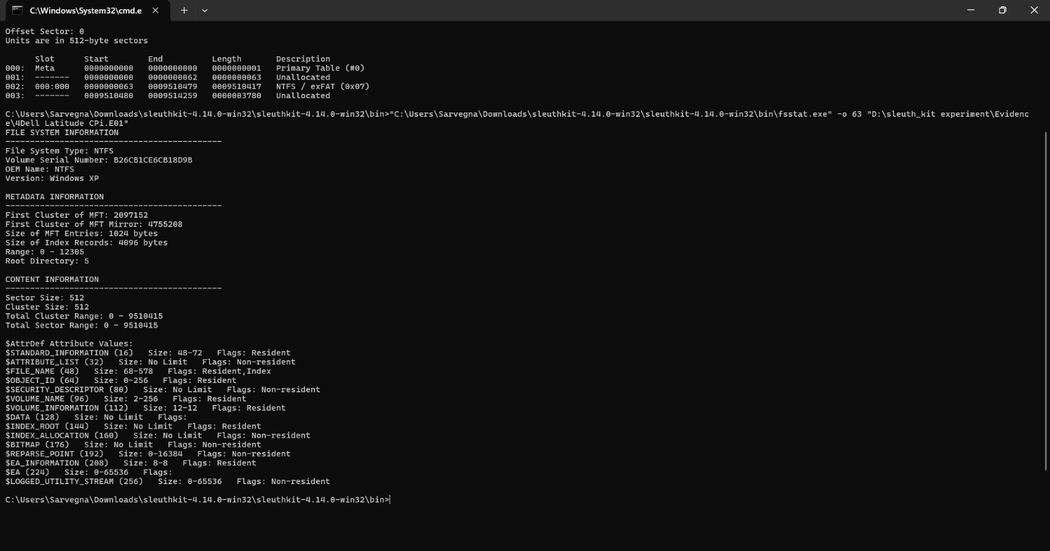
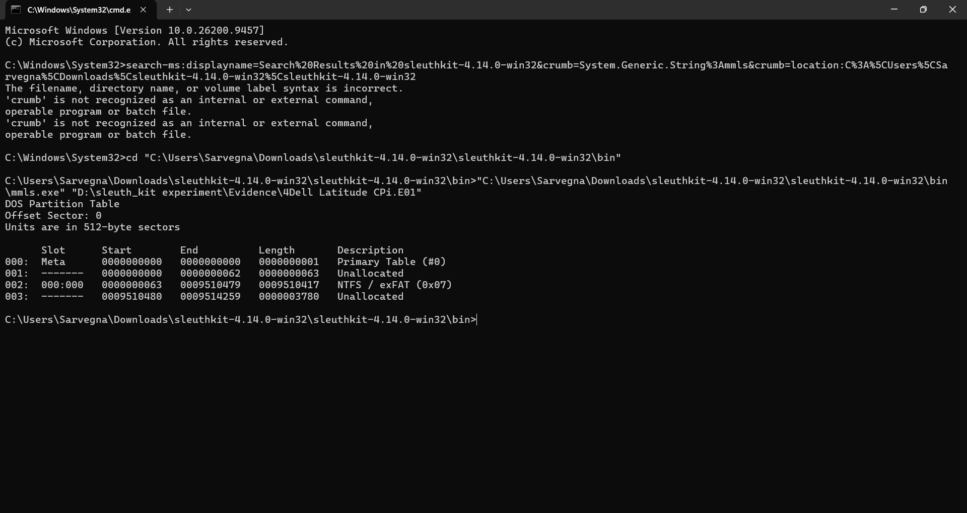
Outcome:
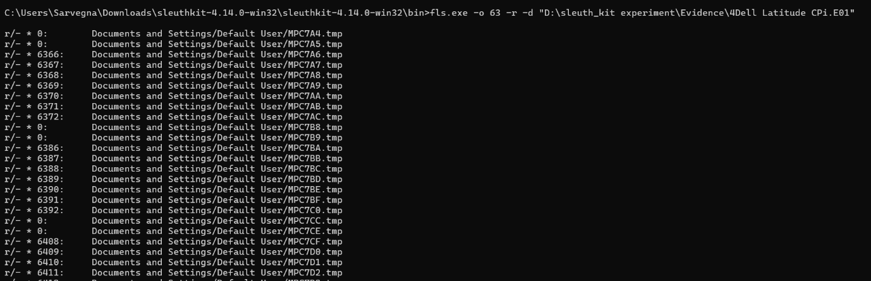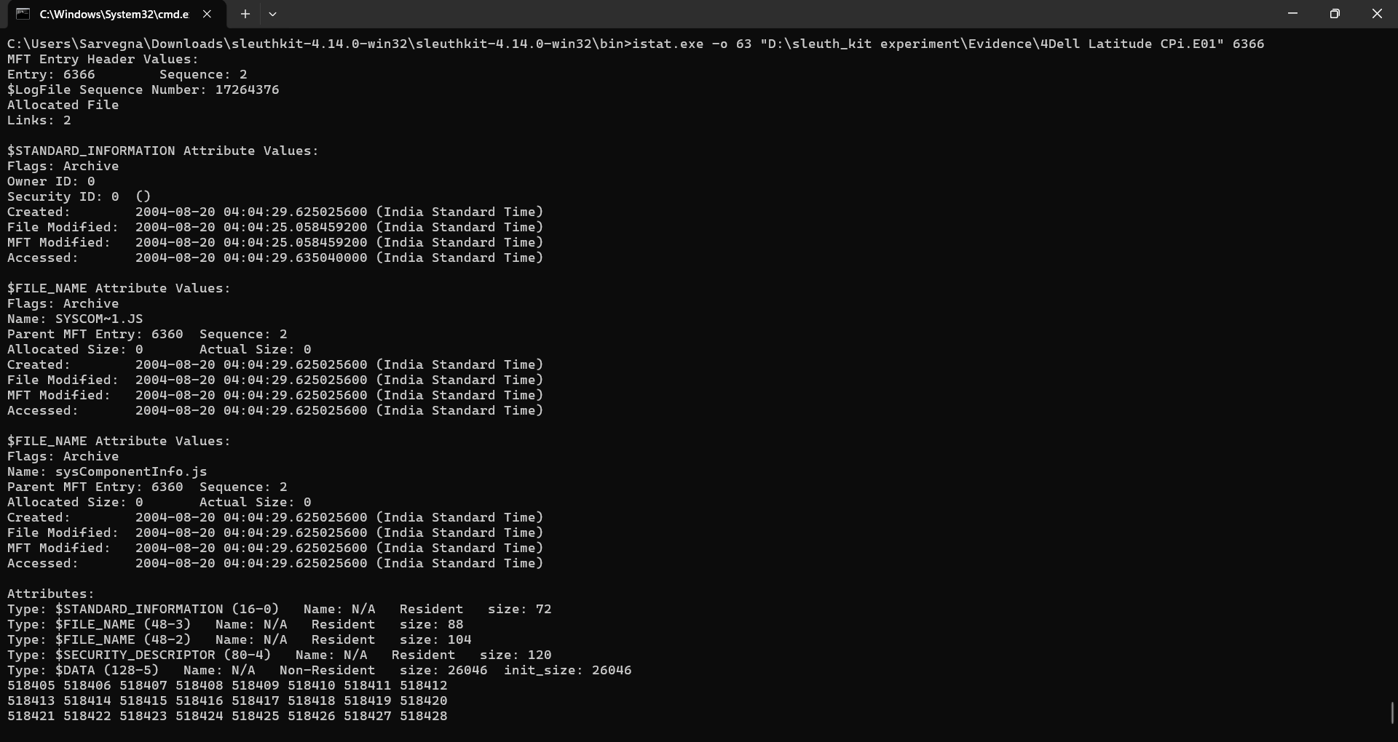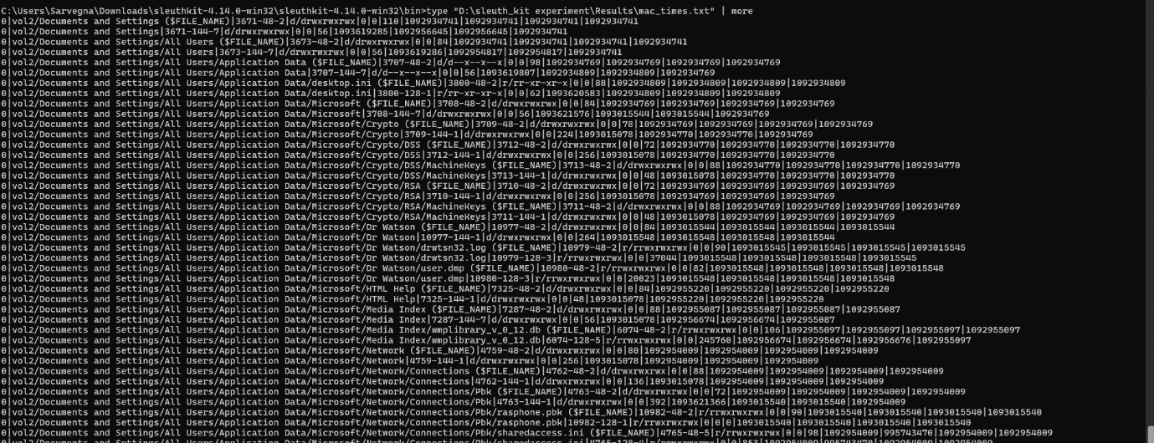

Result: The above experiment Use Sleuthkit to Analyse Digital Evidence is successfully completed.

